Tech Blog需求设计文档

Tech Blog Requirement&Design Document

修改记录
Modification Record
Time | Version | Modifier | Content
2013-08-01 | 1.0 | Charles | Create the document
2013-10-30 | 1.1 | Charles | Add project mission
2013-11-20 | 1.2 | Charles | Add development standard
2013-12-06 | 1.3 | Charles | Add article module design

项目愿景 Mission of the Project

需求摘要 Requirement Summary
该系统是一个可上线的个人技术博客，主要模块包括首页新闻资讯、博文、相册、资源、web应用、留言板以及搜索。该博客用来记录个人的技术学习经验、工作经验和感悟、技术资源等等，并通过博文评论以及留言板与访问者进行交流。

模块划分 Main Models
技术博客
Tech Blog
主页
Home
个人博文
Blog
相册
Album
应用
App
资源
Resource

站内搜索
Search
留言板
Message board

环境与工具介绍 Environment&Tools Introduce
- 开发环境 Development Environment
- Tomcat Server 5.5
- MySQL Server 5.5
- Win7 旗舰版

- 开发工具 Development Tools
- MyEclipse 6.5
- Navicat for MySQL
- Enterprise Architect - UML建模工具
- Photoshop CS4

- 运行环境 Running Environment

开发规范 Development Standard
- 表设计规范
  - 表名以tech_blog_开头
  - 表字段以**_开头，例如表名为tech_blog_admin，字段以admin_开头，外键以[所指表名]_开头，例如外键指向表tech_blog_article，则命名为article_id
  - 每张表预留三个backup字段，以bk_field_*命名，类型为varchar
  - 每个字段必须有注解

- 前端开发规范
  - CGI返回信息格式为：{retcode:0,mess:””}
其中retcode为返回码，0为成功，其他失败，mess为返回信息

- 控制器开发规范
项目使用两类控制器:
- 重定向控制器：负责调用应用接口层组件或数据访问层组件获取数据，使用request传递数据，重定向到制定页面；
- Ajax控制器：作为前端异步获取数据的后台接口，每个接口使用out.print吐出json格式的数据
- Bean开发规范
封装多个DAO，提供更加复杂的数据操作，向控制器层提供接口
- DAO开发规范
只封装简单的数据访问操作
- PO开发规范
可包含非持久化字段
- 工具类开发规范
以**Utils命名

整体架构设计 System Architecture
View视图层(jsp/html)
控制层(Action)
Model应用接口层(Bean)
数据访问层(DAO)
持久层(PO)
数据层(Database)

博文模块 Blog Model
- 用户前台 User Foreground
- 交互稿 Iterative Design
- 用例图 User Case
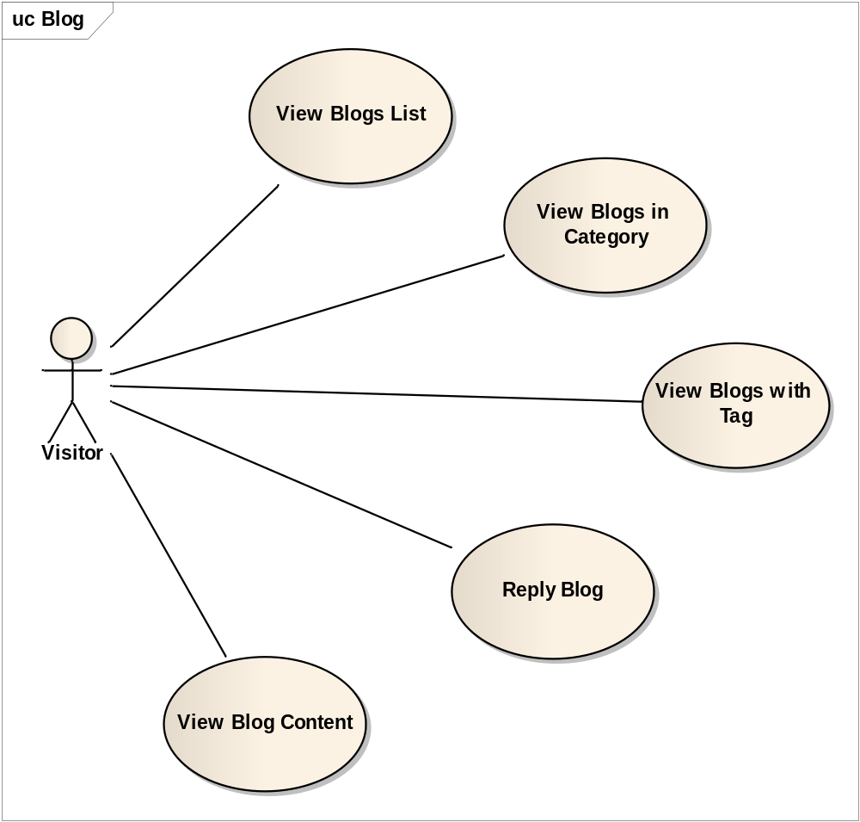

- 序列图 Sequence Graph
Diagram: Reply Blog

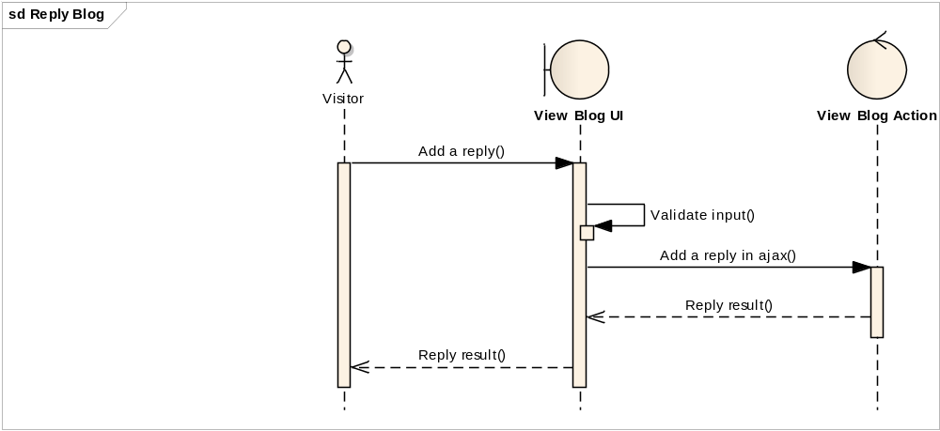
Diagram: View Blog Content

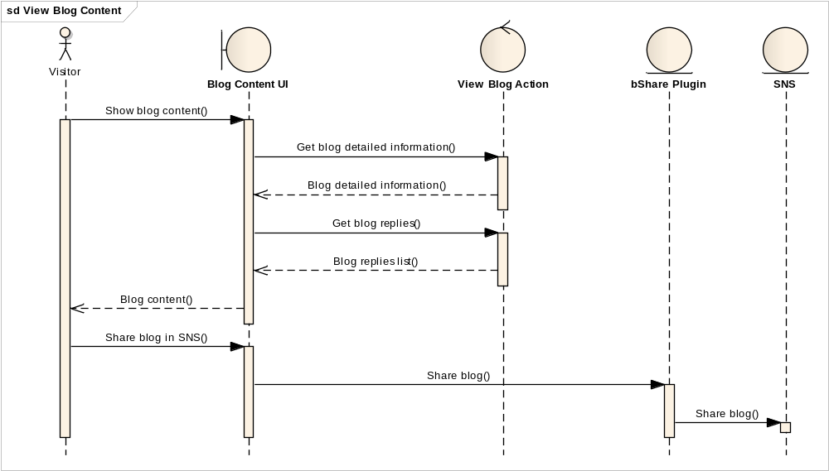
Diagram: View Blogs in Category

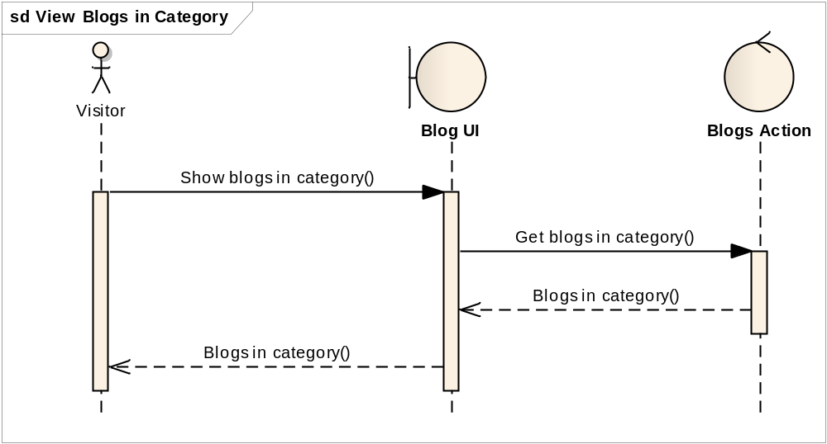
Diagram: View Blogs List

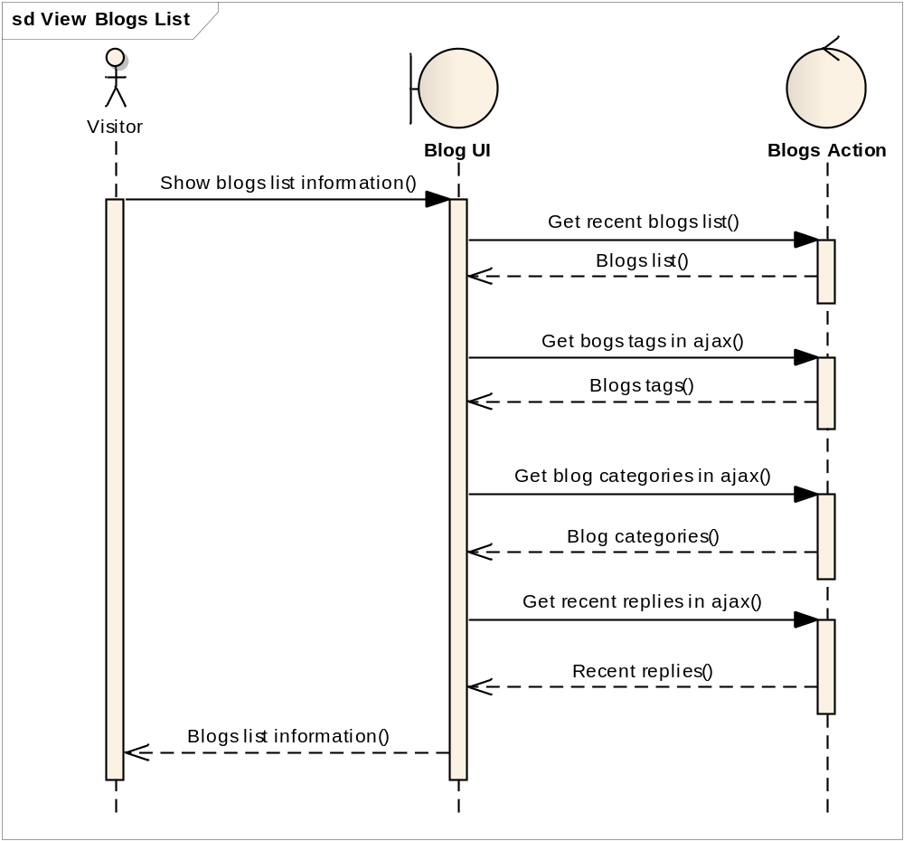
Diagram: View Blogs with Tag

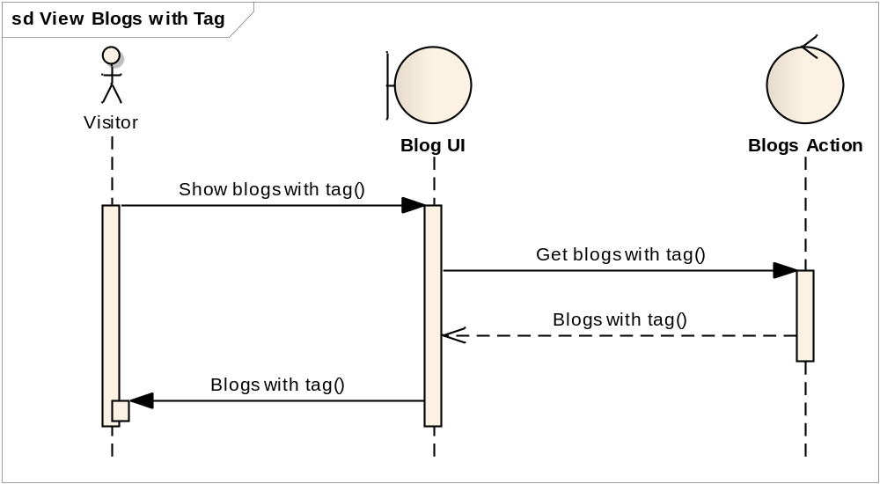

- 数据设计 Data Design

tech_blog_article
Field | Type | Annotation | Remarks
article_id | Smallint | Primary key ID | Automatical increasement
article_title | varchar(100) | Article title
article_content | varchar(20000) | Article content
category_id | Smallint | Article categori | Freign key refers to table tech_blog_category
author_id | smallint | Aticle author | Foreign key refers to table tech_blog_admin
article_post_time | datetime | Create time
article_update_time | datetime | Last update time
article_view_times | smallint | Viewing times
article_reply_times | smallint | Repling times | Increasing by trigger
article_set_top | tinyint | Top-allocated or not | 1 for top-allocated  0 for not
article_state | tinyint | Article state | 1 for published  0 for draft  -1 for deleted
bk_field_1 | varchar | Field for backup
bk_field_2 | varchar | Field for backup
bk_field_3 | varchar | Field for backup

tech_blog_article_category
Field | Type | Annotation | Remarks
category_id | smallint | Primary key ID | Automatical increasement
category_name | varchar(20) | Category name
category_create_time | datetime | Category creating time
category_article_count | smallint | Article count in this category | Increasing by trigger
category_set_top | Tinyint | Top-allocated or not | 1 for top-allocated, 0 for not
category_state | Tinyint | Category state | 1 for available  0 for deleted
bk_field_1 | varchar | Field for backup
bk_field_2 | varchar | Field for backup
bk_field_3 | varchar | Field for backup

tech_blog_article_tag
Field | Type | Annotation | Remarks
tag_id | smallint | Primary key ID | Automatical increasement
tag_name | varchar(20) | Tag name
tag_create_time | timestamp | Tag creating time
article_id | smallint | Article id | Increasing by trigger
tag_state | Tinyint | Tag state | 1 for available  0 for deleted
bk_field_1 | varchar | Field for backup
bk_field_2 | varchar | Field for backup
bk_field_3 | varchar | Field for backup

tech_blog_article_reply
Field | Type | Annotation | Remarks
reply_id | smallint | Primary key ID | Automatical increasement
article_id | smallint | Article ID | Foreign key references article id
reply_visitor_name | varchar(20) | Replier name | Nullable
reply_visitor_email | varchar(30) | Replier email | Nullable
reply_visitor_website | varchar(50) | Replier website | Nullable
reply_content | varchar(500) | Reply content
reply_time | timestamp | Reply time
reply_state | tinyint | Reply state | 1 for available  0 for deleted
bk_field_1 | varchar | Field for backup
bk_field_2 | varchar | Field for backup
bk_field_3 | varchar | Field for backup

tech_blog_aticle_admin_reply
Field | Type | Annotation | Remarks
admin_reply_id | smallint | Primary key ID | Automatical increasement
admin_reply _content | varchar(500) | Reply content
admin_id | smallint | Administrator ID | Foreign key references tech_blog_admin
article_reply_id | smallint | Article reply id | Foreign key refereces tech_blog_article_reply
admin_reply_time | timestamp | Reply time
admin_reply_state | tinyint | Reply state | 1 for available  0 for deleted
bk_field_1 | varchar | Field for backup
bk_field_2 | varchar | Field for backup
bk_field_3 | varchar | Field for backup

- 详细设计 Detailed Design
组件 | 接口 | 功能
ArticleAction | getAllTags | 获取所有博文标签
ArticleAction | addReply | 添加博文评论
ArticleAction | getRecentArticleReplies | 获取最新5条博文评论
ArticleAction | deleteCategory | 逻辑删除已有分类
ViewArticleAction | 跳转控制器 | 根据博文UID，获取博文详细信息，跳转至view_blog.jsp页面进行显示
BlogListAction | 跳转控制器 | 根据页号、分类、标签获取博文列表，跳转至blog_list.jsp页面进行显示
IdEncrypter | encrypt(int id) | 对自增数字ID进行简单加密混淆，生成9位以上的加密字符串
IdEncrypter | decrypt(String encryptedStr) | 对加密字符串进行解密，得到解密后的ID字符串

- 管理员后台 Manager Background
- 交互稿 Iterative Design
- 用例图 User Case
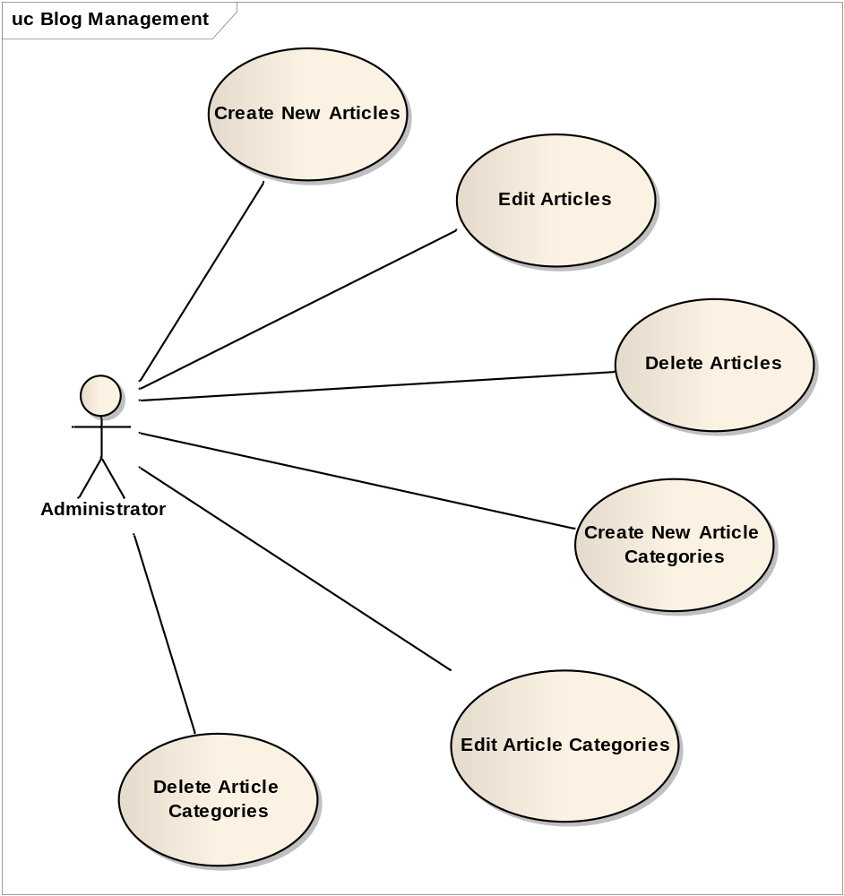
- 序列图 Sequence Graph
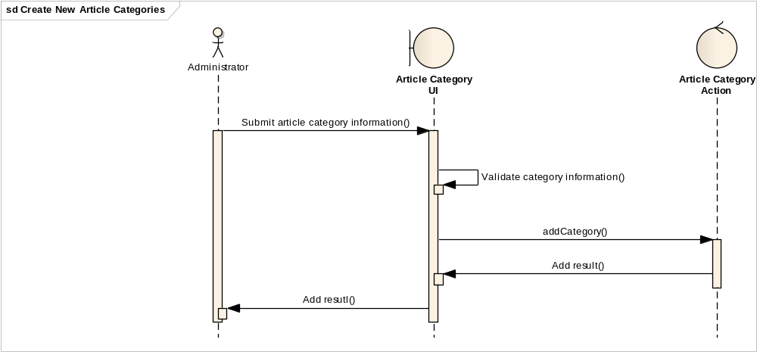

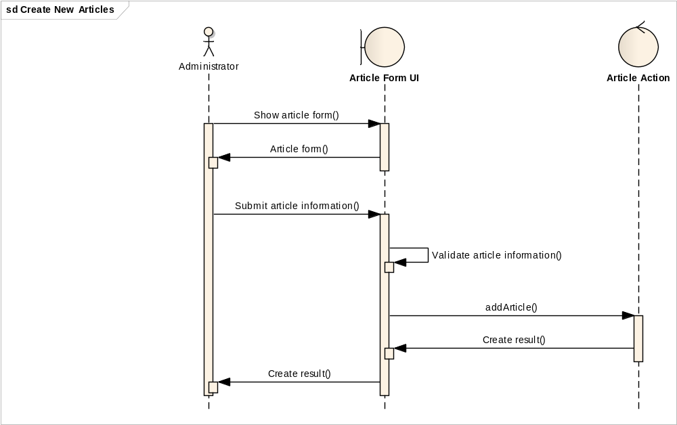
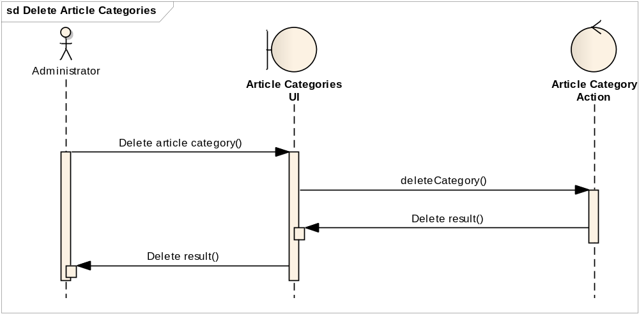

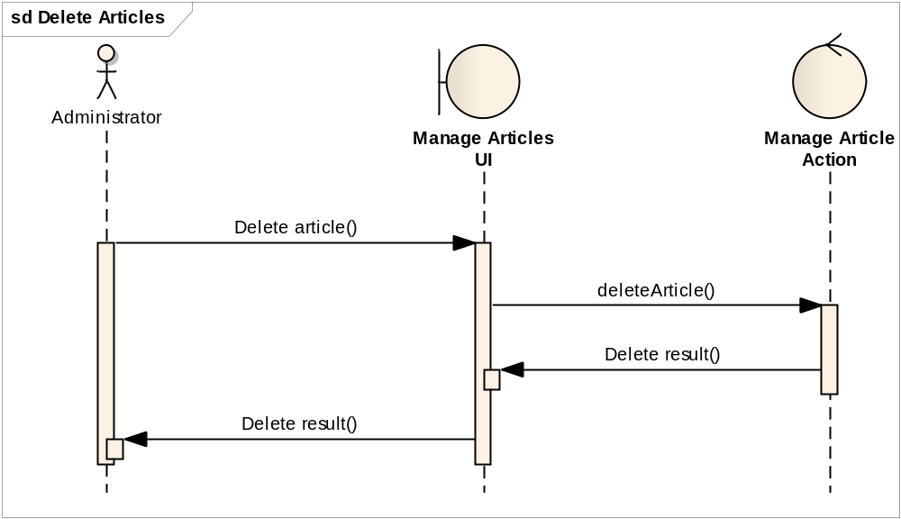

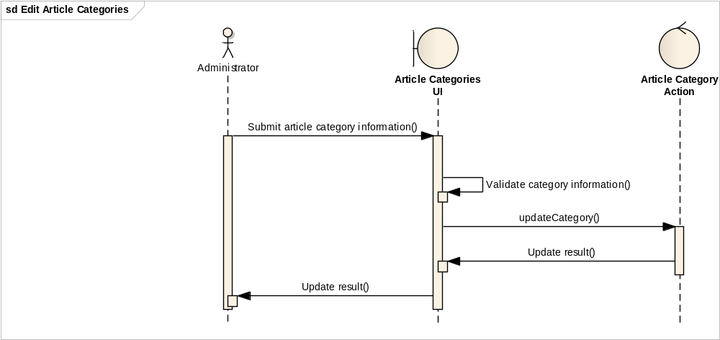

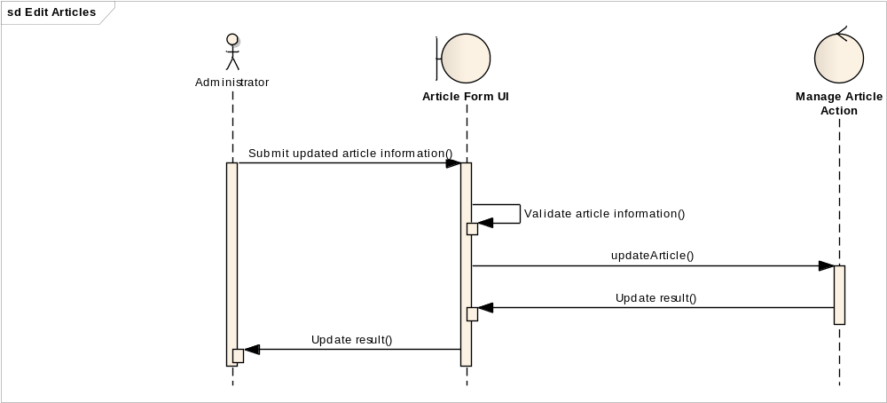

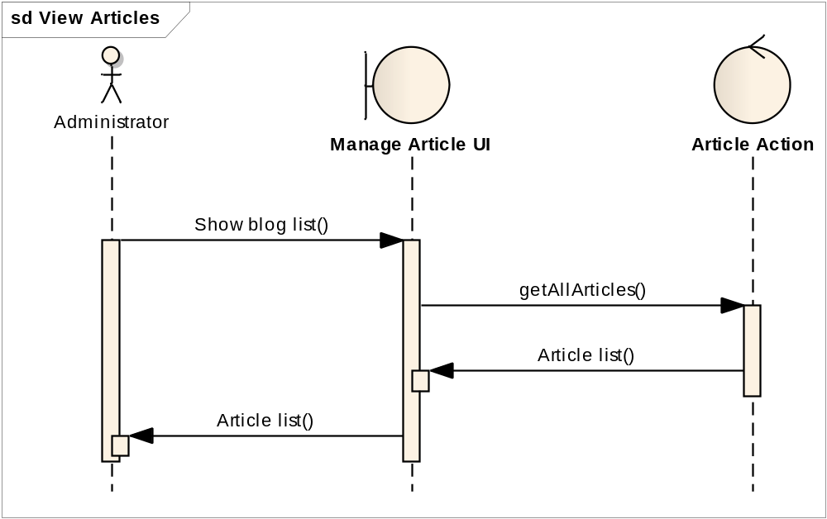
- 数据设计 Data Design
tech_blog_admin
Field | Type | Annotation | Remarks
admin _id | smallint | Primary key ID | Automatical increasement
admin_login_name | varchar(15) | Administrator login name
admin_login_passwd | varchar(15) | Administrator login password
admin _email | varchar(30) | Administrator email
admin_img | varchar(30) | Administrator image
admin_power | smallint | Administrator power | 0: All privilege, including creating other administrators  1: Privilege excluding creating other administrators
bk_field_1 | varchar | Field for backup
bk_field_2 | varchar | Field for backup
bk_field_3 | varchar | Field for backup

- 详细设计 Detailed Design
组件 | 接口 | 功能
ArticleCategoryAction | getAllCategories | 获取所有博文分类
ArticleCategoryAction | addCategory | 添加新分类
ArticleCategoryAction | updateCategory | 更新已有分类
ArticleCategoryAction | deleteCategory | 逻辑删除已有分类
ManageArticleAction | updateArticle | 更新已有博文
ManageArticleAction | deleteArticle | 逻辑删除已有博文
ArticleAction | addArticle | 添加新博文

